OOPS LAB

Experiment -7

NAME- ANMOL YADAV SAP ID- 500083814 ROLLNO- R214220178

**Question: 1**

Write a program in Java to display the names and roll numbers of students. Initialize respective array variables for 10 students. Handle ArrayIndexOutOfBoundsExeption, so that any such problem doesn’t cause illegal termination of program.

**Code:**

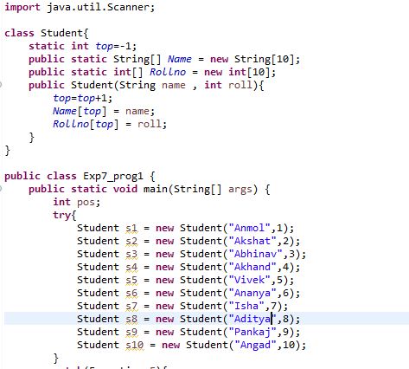

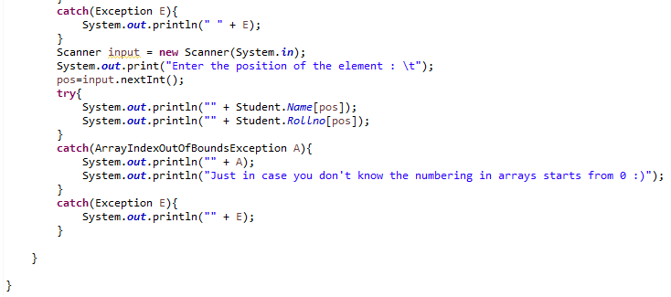

**Output:**

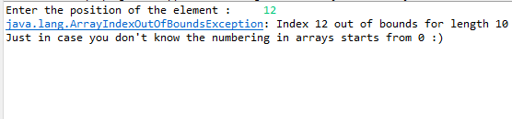

**Question: 2**

Write a Java program to enable the user to handle any chance of divide by zero exception.

**Code:**

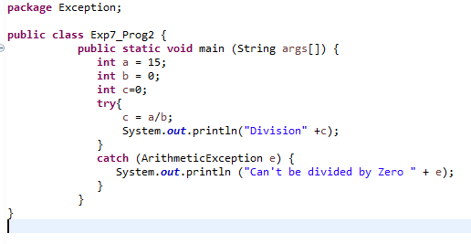

**Output:-**

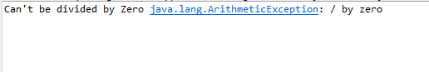

**Question: 3**

Create an exception class, which throws an exception if operand is nonnumeric in calculating modules. (Use command line arguments).

**Code:**

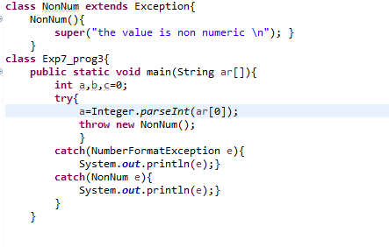

**Output:-**



**Question: 4**

On a single track two vehicles are running. As vehicles are going in same direction there is no problem. If the vehicles are running in different direction there is a chance of collision. To avoid collisions write a Java program using exception handling. You are free to make necessary assumptions.

**Code:-**

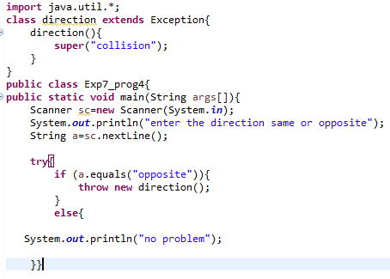

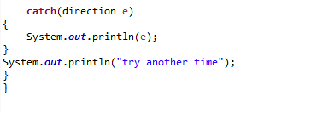

**Output:-**

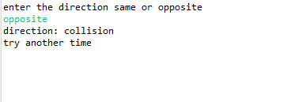

**Question: 5**

1. Write a java program to throw an exception for an employee details.

* If an employee name is a number, a name exception must be thrown.
* If an employee age is greater than 50, an age exception must be thrown.
* Or else an object must be created for the entered employee details

**Code:-**

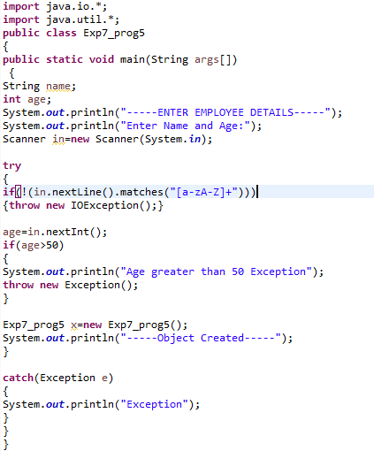

**Output:-**

